Use Case Model

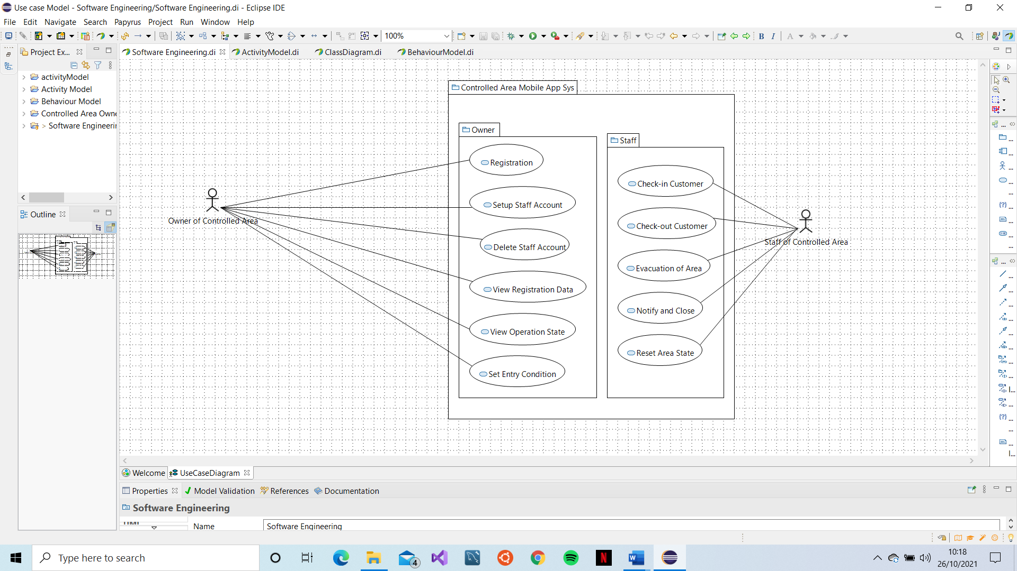

Activity Model

Structural Model (Class Diagram)

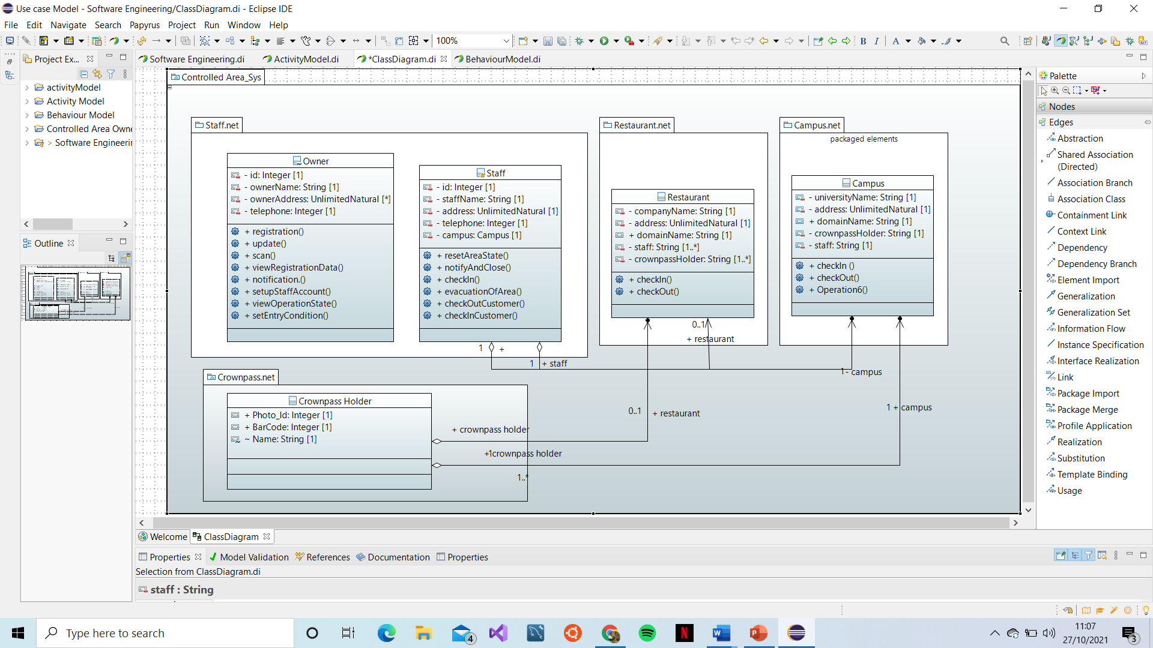

Behaviour Model

